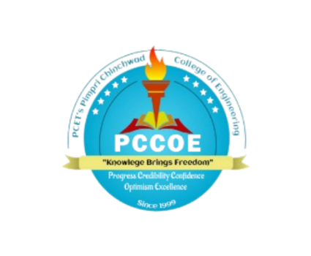

PIMPRI CHINCHWAD EDUCATION TRUST's.
PIMPRI CHINCHWAD COLLEGE OF ENGINEERING
(An Autonomous Institute)

T.Y. B. TECH Year: 2025 – 26 Semester: V
Department: Computer Engineering Division: C
Course: Computer Network and Security

Name Of Student | PRN
- Paritosh Nimhan | 123B1B212
- Parth Patil | 123B1B213
- Meghan Patil | 123B1B218
- Sneha Nalawade | 124B2B022

Report Writing

Public key Cryptography: How RSA revolution secure communication

Introduction
Definition of Cryptography
Cryptography is a technique of securing information and communications using codes to ensure confidentiality, integrity, avaliability and authentication. Thus, preventing unauthorized access to information. The prefix "crypt" means "hidden" and the suffix "graphy" means "writing".
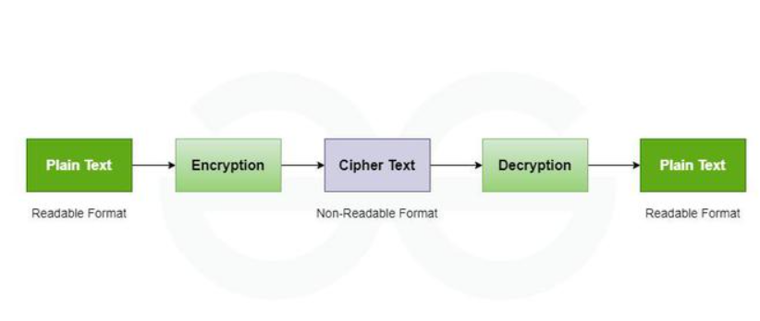

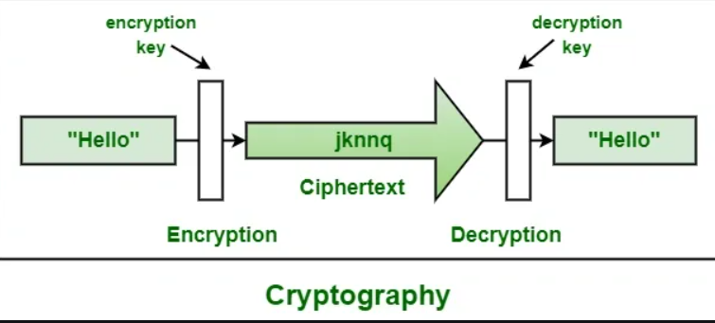

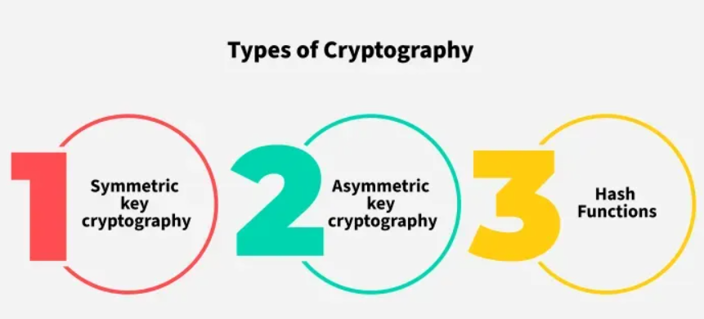

Symmetric Key Cryptography is an encryption system where the sender and receiver of a message use a single common key to encrypt and decrypt messages. Symmetric Key cryptography is faster and simpler but the problem is that the sender and receiver have to somehow exchange keys securely. The most popular symmetric key cryptography systems are Data Encryption Systems (DES) and Advanced Encryption Systems (AES) .

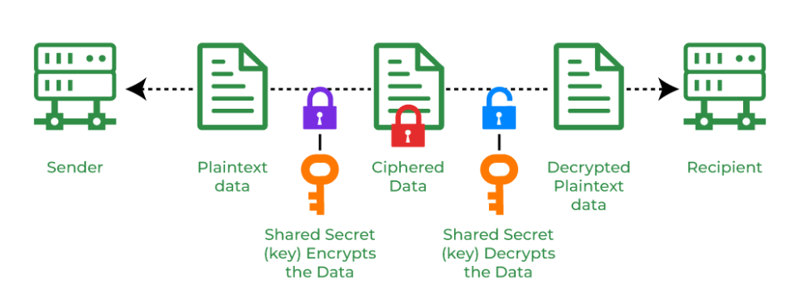
In Asymmetric Key Cryptography a pair of keys is used to encrypt and decrypt information. A sender's public key is used for encryption and a receiver's private key is used for decryption. Public keys and Private keys are different. Even if the public key is known by everyone the intended receiver can only decode it because he holds his private key. The most popular asymmetric key cryptography algorithm is the RSA algorithm
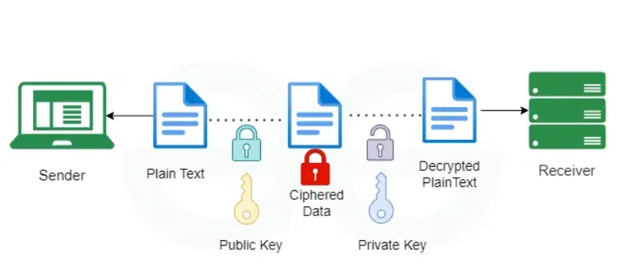

NOTE:PUBLIC KEY CRYPTOGRAPHY=ASYMMETRIC KEY CRYPTOGRAPHY
Public key cryptography uses both public key and private key in order to encrypt and decrypt data. The public key can be distributed commonly but the private key can not be shared with anyone. It is commonly used for two users or two servers in a secure way.
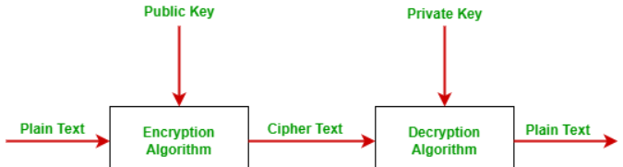

Example: RSA (Rivest-Shamir-Adleman):

RSA(Rivest-Shamir-Adleman) Algorithm is an asymmetric or public-key cryptography algorithm which means it works on two different keys: Public Key and Private Key. The Public Key is used for encryption and is known to everyone, while the Private Key is used for decryption and must be kept secret by the receiver. RSA Algorithm is named after Ron Rivest, Adi Shamir and Leonard Adleman, who published the algorithm in 1977.
The RSA algorithm works on a block cipher concept that converts plain text into cipher text and vice versa.
Example of Asymmetric Cryptography:
If Person A wants to send a message securely to Person B:
- Person A encrypts the message using Person B's Public Key.
- Person B decrypts the message using their Private Key.
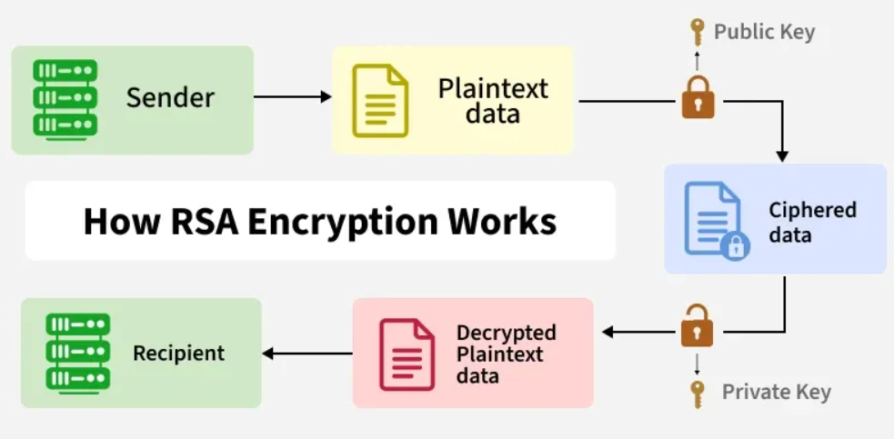

RSA Algorithm is based on factorization of large number and modular arithmetic for encrypting and decrypting data. It consists of three main stages:
- Key Generation: Creating Public and Private Keys
- Encryption: Sender encrypts the data using Public Key to get cipher text.
- Decryption: Decrypting the cipher text using Private Key to get the original data.
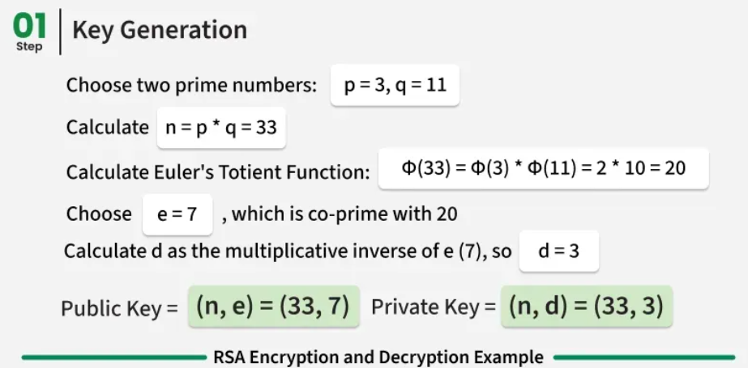

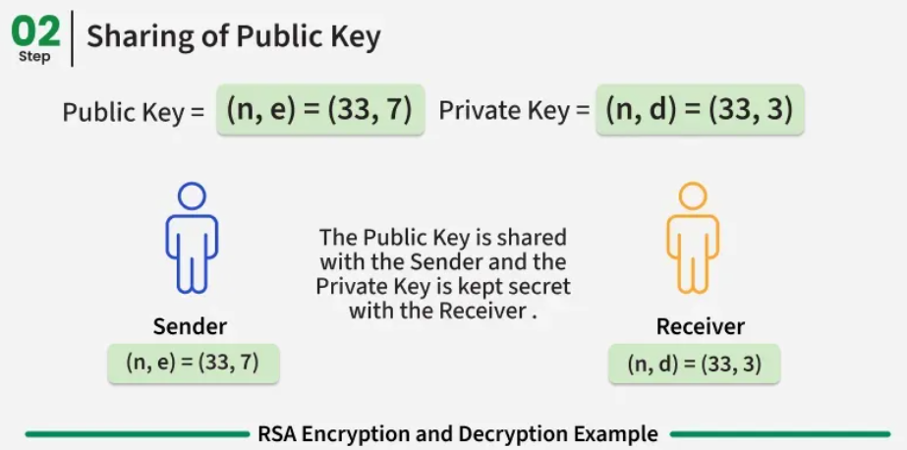

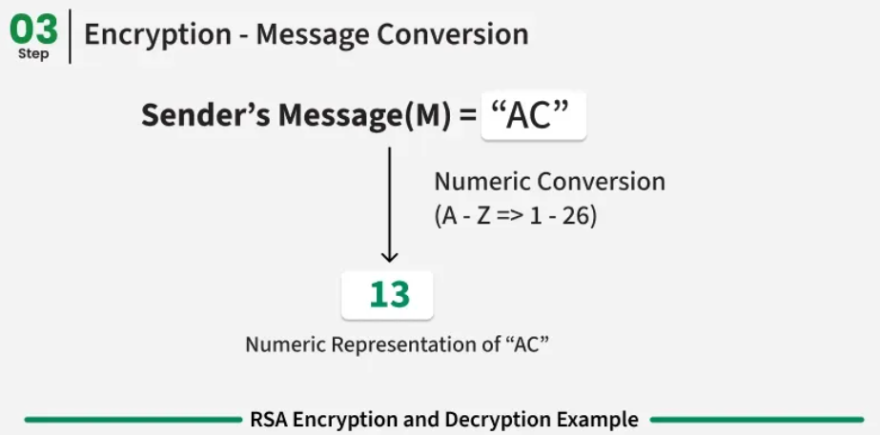
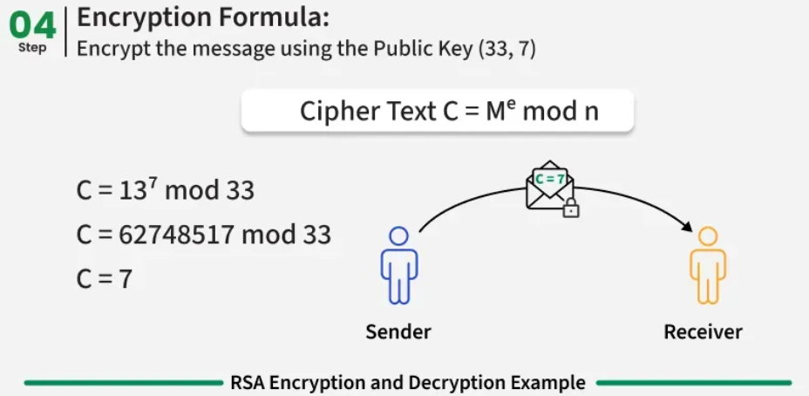

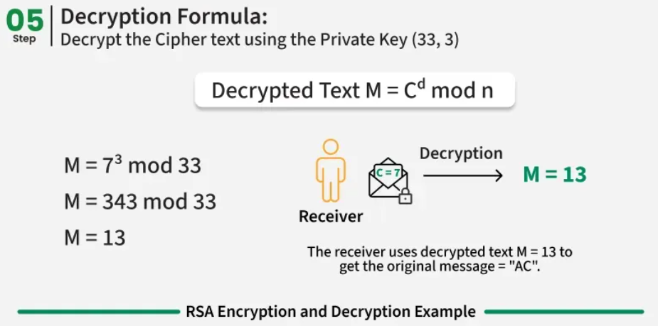

Choose p = 3 and q = 11
Compute n = p * q = 3 * 11 = 33
This n is part of the public key and also used in both encryption and decryption
Computer Euler's function φ(n)
ϕ(n)=(p−1)(q−1)=(3−1)(11−1)=2×10=20
Choose e such that 1 < e < φ(n) and e and φ (n) are coprime. Let e = 7
Compute a value for d such that (d * e) % φ(n) = 1. One solution is d = 3 [(3 * 7) % 20 = 1]
Public key is (e, n) = (7, 33)
Private key is (d, n) = (3, 33)

Encyption:
Let’s say the message M=4 (must be < n)
Ciphertext C=M^e modn=4^3 mod33=64 mod33=31
Encrypted Message = 31

Decryption:
M=C^d modn=31^7 mod33
Use modular Exponential
- 31^2 = 961 mod33=4
- 31^4 = (31^2)^2 = 16
- 31^7 = 31.31^2.31^4 = 31.4.16 = 1984 mod 33
Now, 1984 mod 33 = 4
Decrypted Message= 4

How RSA revolution secure communication
- RSA was the first practical public-key encryption system. It replaced older methods that required both parties to share the same secret key.
- You can share your public key. Anyone can encrypt a message with it, but only you can decrypt it using your private key.
- RSA became the foundation for SSL/TLS, the technology behind HTTPS websites (the lock symbol in browsers). This made online banking, shopping, and messaging secure
- Messages encrypted with RSA are impossible to read without the private key.

Advantages of RSA
- Strong mathematical foundation: Very Secure, it’s almost impossible to break because it uses very large prime numbers.
- Security: RSA algorithm is considered to be very secure and is widely used for secure data transmission.
- Public-key cryptography: RSA algorithm is a public-key cryptography algorithm, which means that it uses two different keys for encryption and decryption. The public key is used to encrypt the data, while the private key is used to decrypt the data.
- Digital signatures: RSA algorithm can be used for digital signatures, which means that a sender can sign a message using their private key, and the receiver can verify the signature using the sender's public key.

Limitations of RSA
- Slow processing speed: RSA algorithm is slower than other encryption algorithms, especially when dealing with large amounts of data.
- Large key size: RSA algorithm requires large key sizes to be secure, which means that it requires more computational resources and storage space.
- Complexity: The RSA algorithm is a sophisticated mathematical technique that some individuals may find challenging to comprehend and use.

